Dis-Mex-Colima-Two Seated Figures

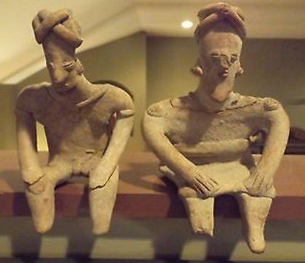

Formal Label: Two Seated Colima Figures

Accession Number:

**LC Classification: F1219**

Date or Time Horizon: 100-900 AD/CE

Geographical Area: west Mexico

Cultural Affiliation: Colima

Medium: terracotta

Dimensions:

Weight:

Condition:

Provenance:

**Discussion:** TheLos Ortices era, which began around 500 BCE, witnessed the beginning of shaft tombs and a distinctive ceramic style called *rojo bruñido,* or burnished red. The Comala site (100 to 600 CE) perfected burnished red pottery with their most famous creation the hairless fattened dog.

**References:**

Reynolds, Richard. 1993. The ancient art of Colima, Mexico. Walnut Creek, CA : Squibob Press.